1. **Authentication Provider**:
   1. We know that this is interface and we have to implement it if we want our own implementation.
   2. Let’s understand the methods inside it if we have to override them.
2. 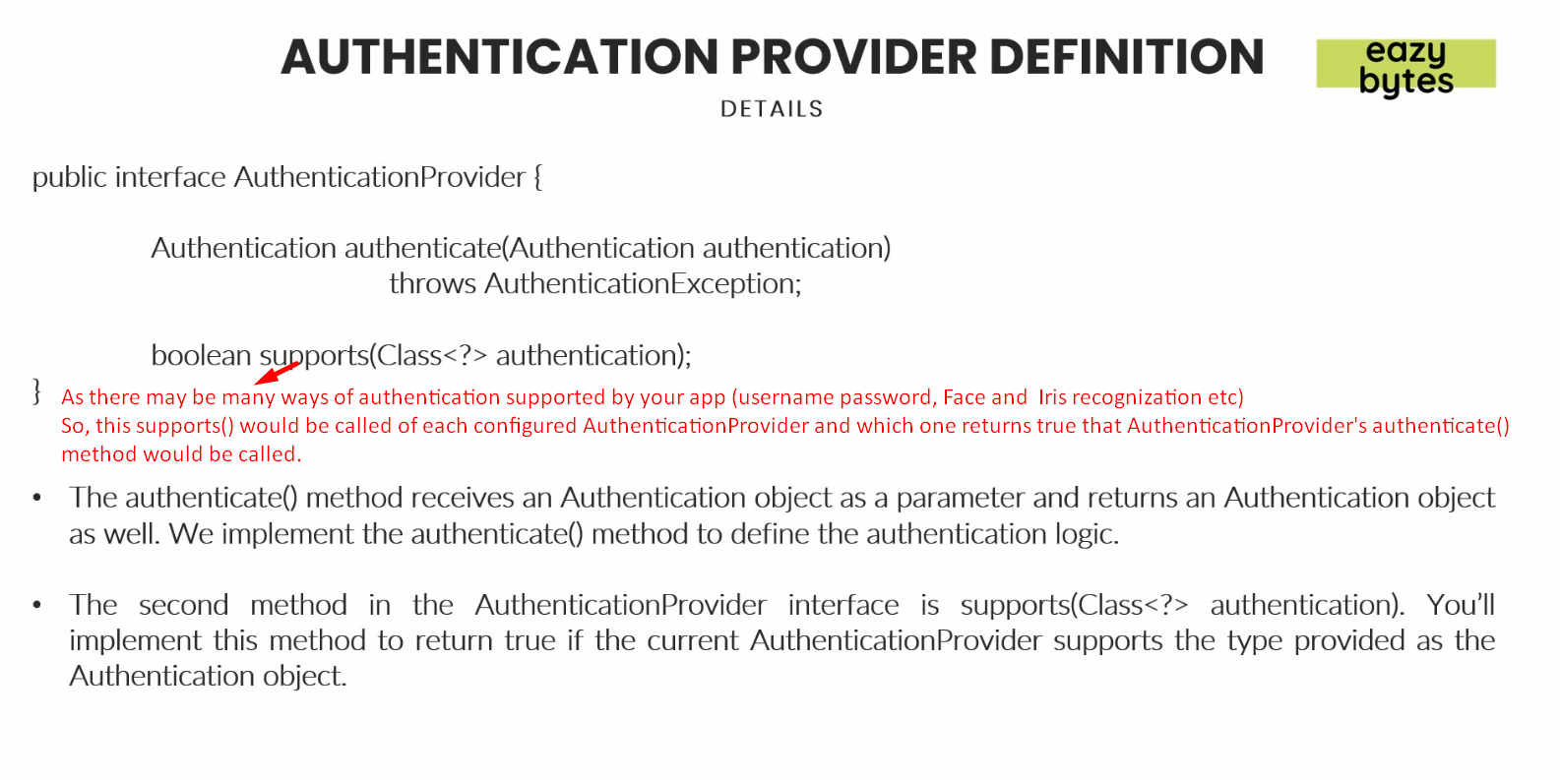
3. **NOTE**: Before starting the following snapshot, know that there may be more than one AuthenticationProvider configured, one for each supported authentication type such as (Face/Iris recognition, finger Print, Username etc)   
   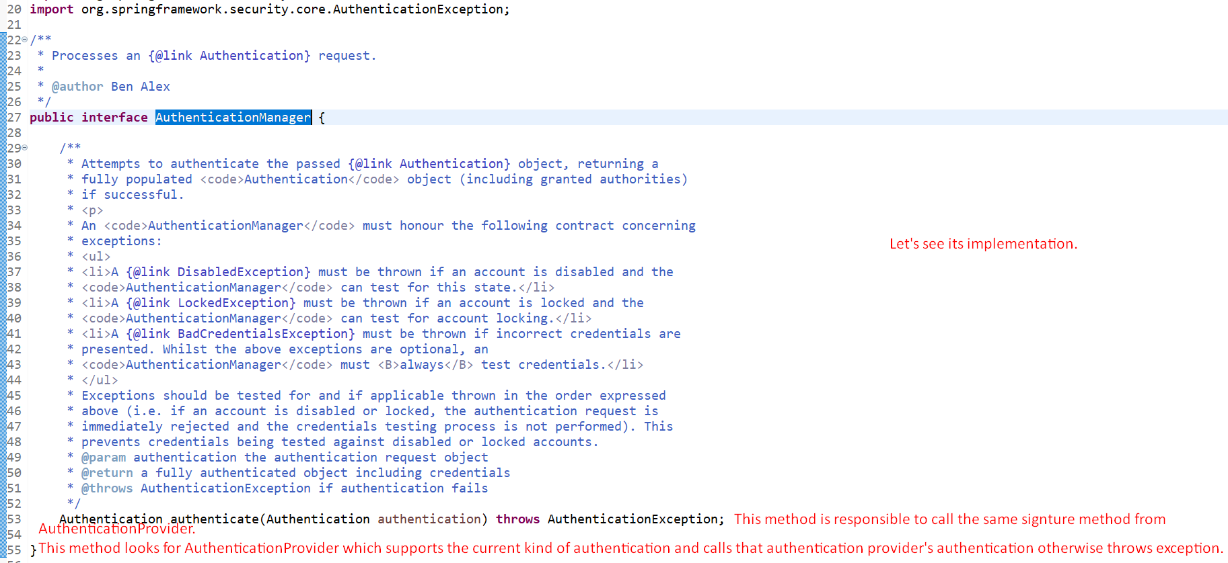
4. **NOTE**: There is always one AuthenticationManager but there may be more than one AuthenticationProvider.
5. 
6. 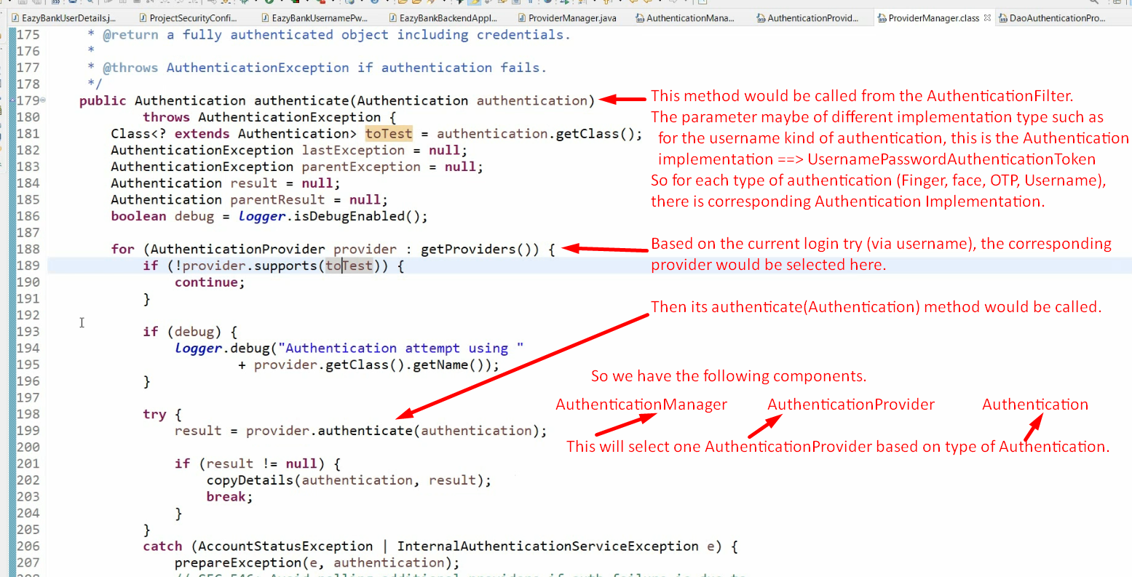
7. 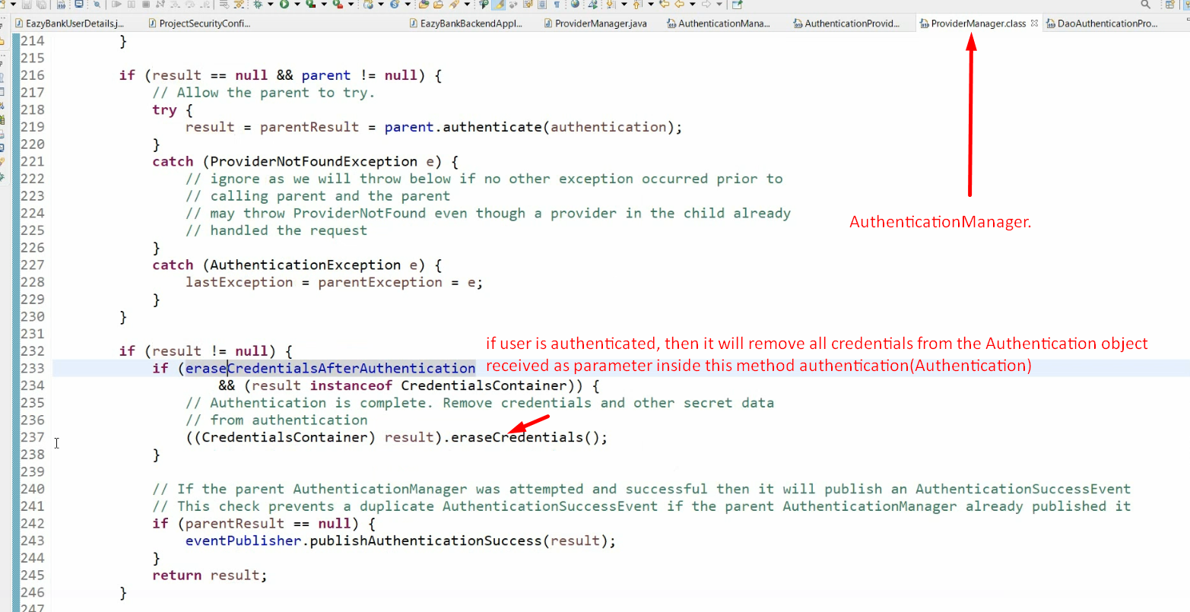
8. 